**Azure AI Vision Services**

The Azure AI Vision service gives you access to advanced algorithms that process images and return information based on the visual features you're interested in. The following table lists the major product categories.

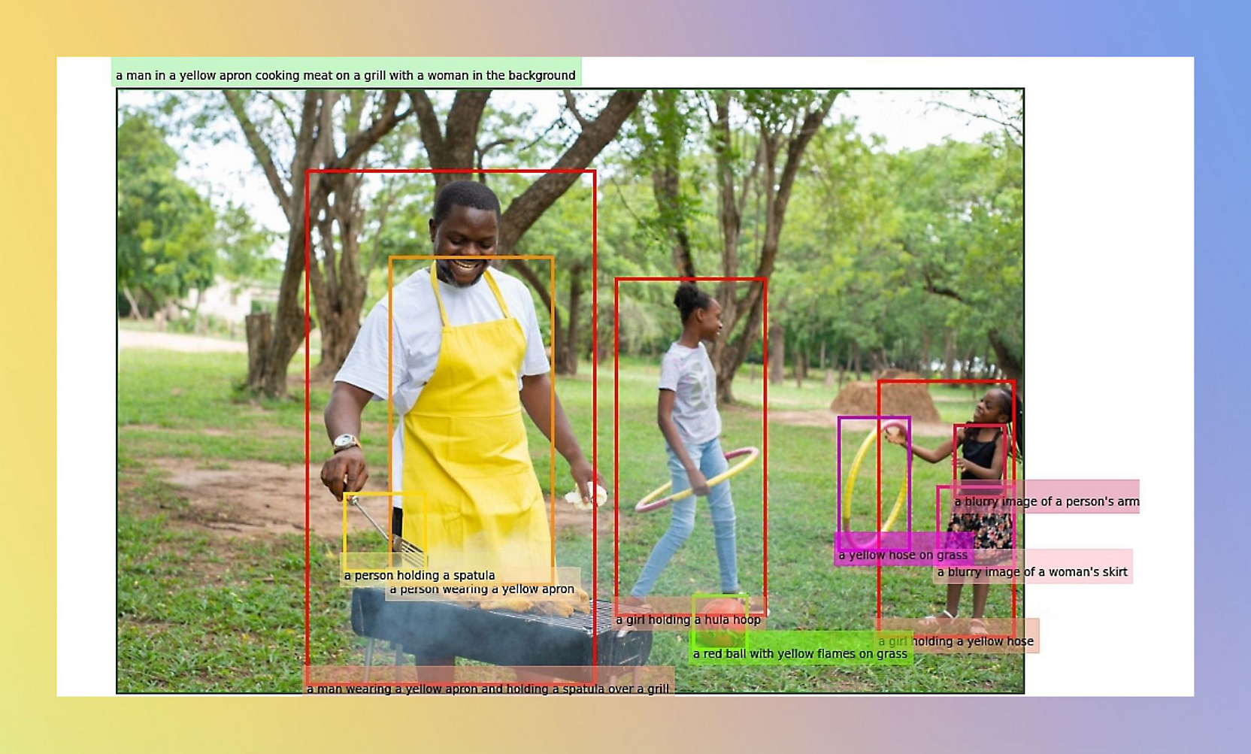

<https://learn.microsoft.com/en-us/azure/ai-services/computer-vision/overview>

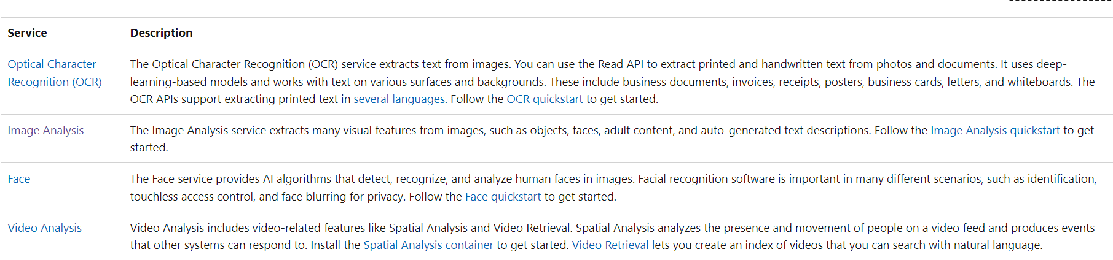

**OCR - Optical Character Recognition**

OCR or Optical Character Recognition is also referred to as **text recognition or text extraction**. Machine-learning-based OCR techniques allow you to extract printed or handwritten text from images such as posters, street signs and product labels, as well as from documents like articles, reports, forms, and invoices. The text is typically extracted as words, text lines, and paragraphs or text blocks, enabling access to digital version of the scanned text. This eliminates or significantly reduces the need for manual data entry.

**How to use OCR**

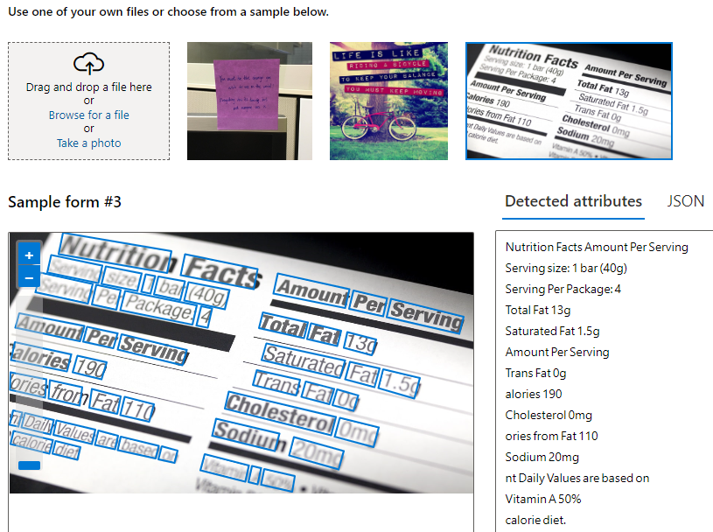

**OCR common features**

* Printed and handwritten text extraction in supported languages
* Pages, text lines and words with location and confidence scores
* Support for mixed languages, mixed mode (print and handwritten)
* Available as Distroless Docker container for on-premises deployment

**Input requirements**

The **Read** API takes images and documents as its input. The images and documents must meet the following requirements:

* Supported file formats are JPEG, PNG, BMP, PDF, and TIFF.
* For PDF and TIFF files, up to 2,000 pages (only the first two pages for the free tier) are processed.
* The file size of images must be less than 500 MB (4 MB for the free tier) with dimensions at least 50 x 50 pixels and at most 10,000 x 10,000 pixels. PDF files don't have a size limit.
* The minimum height of the text to be extracted is 12 pixels for a 1024 x 768 image, which corresponds to about 8-point font text at 150 DPI.

**OCR supported languages**

<https://learn.microsoft.com/en-us/azure/ai-services/computer-vision/language-support#optical-character-recognition-ocr>

**Image Analysis**

The Azure AI Vision Image Analysis service can extract a wide variety of **visual features** from your images. For example, it can determine whether an image contains **adult content, find specific brands or objects, or find human faces.**

**Image requirements**

* **File size**: The image file must be less than 4 megabytes (MB) for the 3.2 version of the API and 20 MB for the 4.0 version.
* **Image format**: The image must be in JPEG, PNG, GIF, BMP, WEBP, ICO, TIFF, or MPO format.
* **Image dimensions**: The image dimensions must be greater than 50 x 50 pixels. For the Read API, the dimensions must be between 50 x 50 and 16,000 x 16,000 pixels.

**Analyze Image**

**Generate image captions**

Generate a caption of an image in human-readable language, using complete sentences. Computer Vision's algorithms generate captions based on the objects identified in the image.

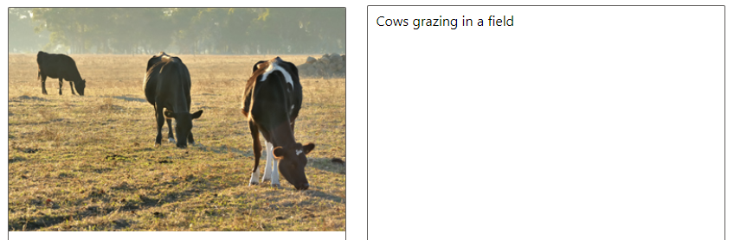

**Detect objects**  
Object detection is similar to tagging, but the API returns the bounding box coordinates for each tag applied. For example, if an image contains a dog, cat and person, the Detect operation lists those objects together with their coordinates in the image. You can use this functionality to process further relationships between the objects in an image. It also lets you know when there are multiple instances of the same tag in an image.

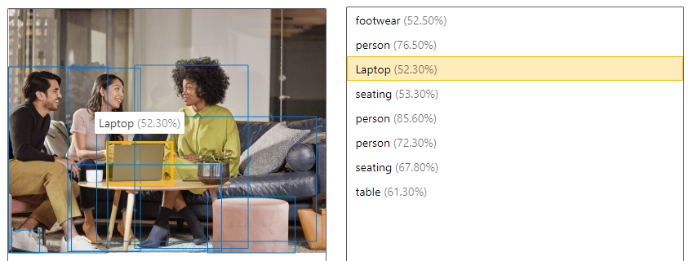

**Tag visual features**  
Identify and tag visual features in an image, from a set of thousands of recognizable objects, living things, scenery, and actions. When the tags are ambiguous or not common knowledge, the API response provides hints to clarify the context of the tag. Tagging isn't limited to the main subject, such as a person in the foreground, but also includes the setting (indoor or outdoor), furniture, tools, plants, animals, accessories, gadgets, and so on.

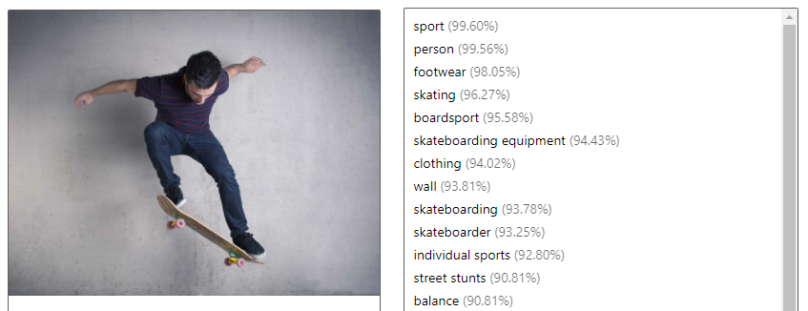

**Azure AI Face service**

The Azure AI Face service provides AI algorithms that **detect, recognize, and analyze human faces in images**. Facial recognition software is important in many scenarios, such as identification, touchless access control, and automatic face blurring for privacy.

**Example use cases**

**Verify user identity**: Verify a person against a **trusted face image**. This verification could be used to grant access to digital or physical properties such as a bank account, access to a building, and so on. In most cases, the trusted face image could come from a government-issued ID such as a passport or driver’s license, or it could come from an enrollment photo taken in person. During verification, liveness detection can play a critical role in verifying that the image comes from a real person, not a printed photo or mask. For more details on verification with liveness, see the [liveness tutorial](https://learn.microsoft.com/en-us/azure/ai-services/computer-vision/tutorials/liveness). For identity verification without liveness, follow the [quickstart](https://learn.microsoft.com/en-us/azure/ai-services/computer-vision/quickstarts-sdk/identity-client-library).

**Liveness detection**: Liveness detection is **an anti-spoofing feature** that checks whether a user is physically present in front of the camera. It's used to prevent spoofing attacks using a printed photo, recorded video, or a 3D mask of the user's face. [Liveness tutorial](https://learn.microsoft.com/en-us/azure/ai-services/computer-vision/tutorials/liveness)

**Touchless access control**: Compared to today’s methods like cards or tickets, opt-in face identification enables an enhanced access control experience while **reducing the hygiene and security risks from card sharing, loss, or theft.** Facial recognition assists the check-in process with a human in the loop for check-ins in airports, stadiums, theme parks, buildings, reception kiosks at offices, hospitals, gyms, clubs, or schools.

**Face redaction: Redact or blur detected faces** of people recorded in a video **to protect their privacy**.

**Input requirements**

General image input requirements:

* The supported input image formats are JPEG, PNG, GIF (the first frame), BMP.
* The image file size should be no larger than 6 MB.

Input requirements for face detection:

* The minimum detectable face size is 36 x 36 pixels in an image that is no larger than 1920 x 1080 pixels. Images with larger than 1920 x 1080 pixels have a proportionally larger minimum face size. Reducing the face size might cause some faces not to be detected, even if they're larger than the minimum detectable face size.
* The maximum detectable face size is 4096 x 4096 pixels.
* Faces outside the size range of 36 x 36 to 4096 x 4096 pixels will not be detected.

Input requirements for face recognition:

* Some faces might not be recognized because of photo composition, such as:
  + Images with extreme lighting, for example, severe backlighting.
  + Obstructions that block one or both eyes.
  + Differences in hair type or facial hair.
  + Changes in facial appearance because of age.
  + Extreme facial expressions.

**Face recognition operations**

**Identification**

Face identification can address "one-to-many" matching of one face in an image to a set of faces in a secure repository. Match candidates are returned based on how closely their face data matches the query face. This scenario is used in granting building or airport access to a certain group of people or verifying the user of a device.

The following image shows an example of a database named "myfriends". Each group can contain up to 1 million different person objects. Each person object can have up to 248 faces registered.

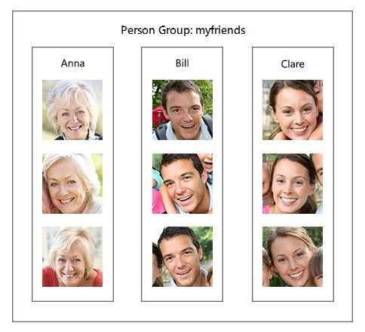

After you create and train a group, you can do identification against the group with a new detected face. If the face is identified as a person in the group, the person object is returned.

**Verification**

The verification operation answers the question, "Do these two faces belong to the same person?".

Verification is also a "one-to-one" matching of a face in an image to a single face from a secure repository or photo to verify that they're the same individual. Verification can be used for access control, such as a banking app that enables users to open a credit account remotely by taking a new picture of themselves and sending it with a picture of their photo ID. It can also be used as a final check on the results of an Identification API call.

**Find similar faces**

The Find Similar operation does face matching between a target face and a set of candidate faces, finding a smaller set of faces that look similar to the target face. This is useful for doing a face search by image.

The service supports two working modes, **matchPerson** and **matchFace**. The **matchPerson** mode returns similar faces after filtering for the same person by using the [Verify API](https://learn.microsoft.com/en-us/rest/api/face/face-recognition-operations/verify-face-to-face). The **matchFace** mode ignores the same-person filter. It returns a list of similar candidate faces that may or may not belong to the same person.

The following example shows the target face:



And these images are the candidate faces:

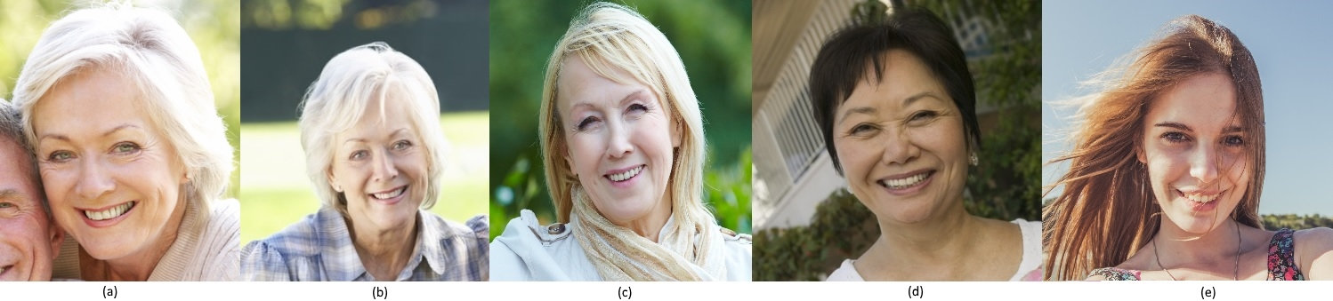

To find four similar faces, the **matchPerson** mode returns A and B, which show the same person as the target face. The **matchFace** mode returns A, B, C, and D, which is exactly four candidates, even if some aren't the same person as the target or have low similarity.

**Group faces**

The Group operation divides a set of unknown faces into several smaller groups based on similarity. Each group is a disjoint proper subset of the original set of faces. It also returns a single "messyGroup" array that contains the face IDs for which no similarities were found.

All of the faces in a returned group are likely to belong to the same person, but there can be several different groups for a single person. Those groups are differentiated by another factor, such as expression, for example

**Video Analysis**

Video Analysis includes video-related features like **Spatial Analysis and Video Retrieval**.

**Spatial Analysis**

You can use Azure AI Vision Spatial Analysis **to detect the presence and movements of people in video**. Ingest video streams from cameras, extract insights, and generate events to be used by other systems. The service can do things like count **the number of people entering a space** or **measure compliance with face mask** and **social distancing guidelines**. By processing video streams from physical spaces, you can learn how people use them and maximize the space's value to your organization.

**People counting**

This operation counts the number of people in a specific zone over time using the *PersonCount* operation. It generates an independent count for each frame processed without attempting to track people across frames. This operation can be used to estimate the number of people in a space or generate an alert when a person appears.



**Entrance Counting**

This feature monitors how long people stay in an area or when they enter through a doorway. This monitoring can be done using the PersonCrossingPolygon or PersonCrossingLine operations. In retail scenarios, these operations can be used to measure wait times for a checkout line or engagement at a display. Also, these operations could measure foot traffic in a lobby or a specific floor in other commercial building scenarios.



**Social distancing and face mask detection**

This feature analyzes how well people follow social distancing requirements in a space. The system uses the *PersonDistance* operation to automatically calibrate itself as people walk around in the space. Then it identifies when people violate a specific distance threshold (6 ft. or 10 ft.).



Spatial Analysis can also be configured to detect if a person is wearing a protective face covering such as a mask. A mask classifier can be enabled for the PersonCount, PersonCrossingLine, and PersonCrossingPolygon operations by configuring the ENABLE_FACE_MASK_CLASSIFIER parameter.

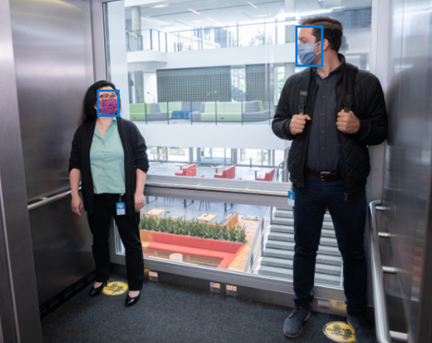

**Video Retrieval**

Video Retrieval is a service that lets **you create a search index, add documents (videos and images) to it, and search with natural language**. Developers can define metadata schemas for each index and ingest metadata to the service to help with retrieval. Developers can also specify what features to extract from the index (vision, speech) and filter their search based on features.

**Video requirements**

* **Video format**

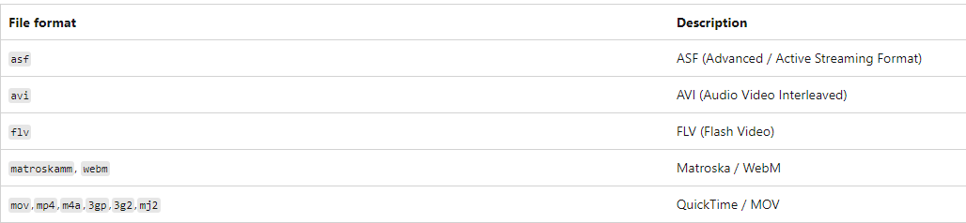

* **Video codec**

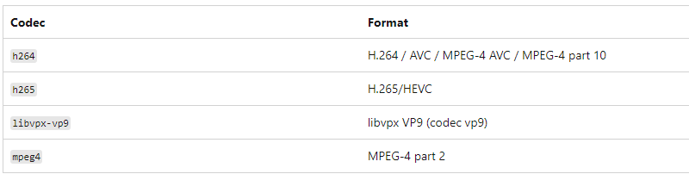

* **Supported audio codecs**

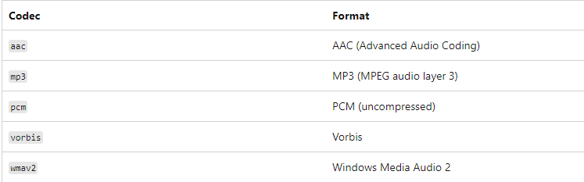

**Types of functions/APIs available**

<https://learn.microsoft.com/en-us/azure/ai-services/computer-vision/>

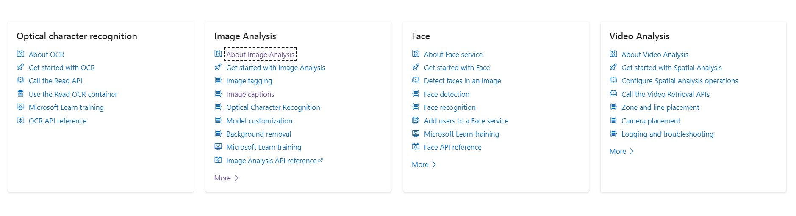

**Vision Studio**

[Vision Studio](https://portal.vision.cognitive.azure.com/) is a set of UI-based tools that lets you explore, build, and integrate features from Azure AI Vision.

Vision Studio lets you try several service features and sample their returned data in a quick, straightforward manner. Using Vision Studio, you can start experimenting with the services and learning what they offer without needing to write any code. Then, use the available client libraries and REST APIs to embed these services into your own applications.

<https://learn.microsoft.com/en-us/azure/ai-services/computer-vision/overview-vision-studio>

To use Vision Studio, you need an **Azure subscription and a resource for Azure AI services** for authentication. You can also use this resource to call the services in the try-it-out experiences. Follow these steps to get started.

1. Create an **Azure subscription** if you don't have one already. You can [create one for free](https://azure.microsoft.com/free/ai/).
2. Go to the [Vision Studio website](https://portal.vision.cognitive.azure.com/). If it's your first visit, a popup window prompts you to sign in to Azure and then choose or create a Vision resource. You can skip this step and do it later.

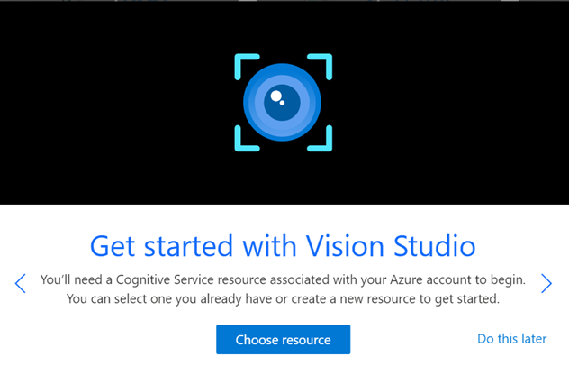

1. Select **Choose resource**, then select an existing resource within your subscription. If you want to create a new one, select **Create a new resource**. Then enter information for your new resource, such as a name, location, and resource group.

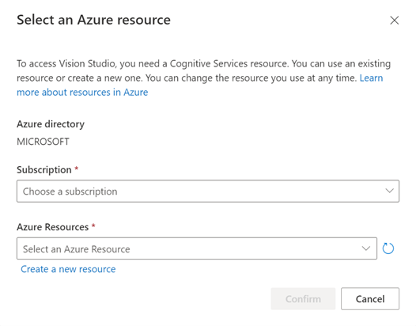

**Tip**

* + For lower latency, select a location for your Azure resource that's closest to you.
  + If you use the free pricing tier, you can keep using the Vision service even after your Azure free trial or service credit expires.

1. Select **Create resource**. After your resource is created, you can try the different features offered by Vision Studio.

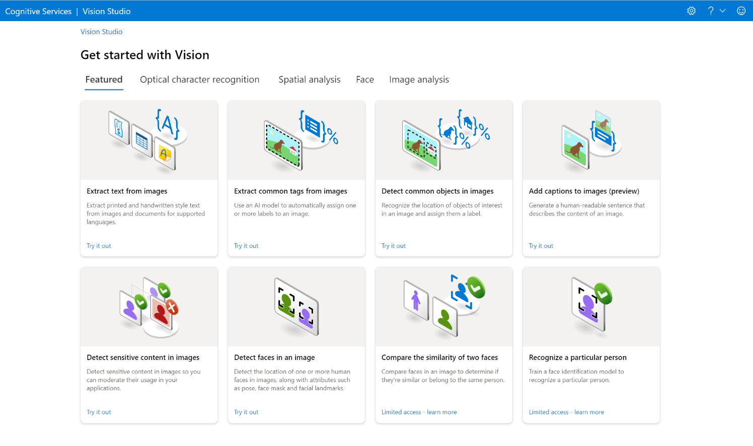

1. From here, you can select any of the different features offered by Vision Studio.

**Difference between Azure AI Services resource and Azure AI services multi-service account**

* Azure AI services multi-service resource:

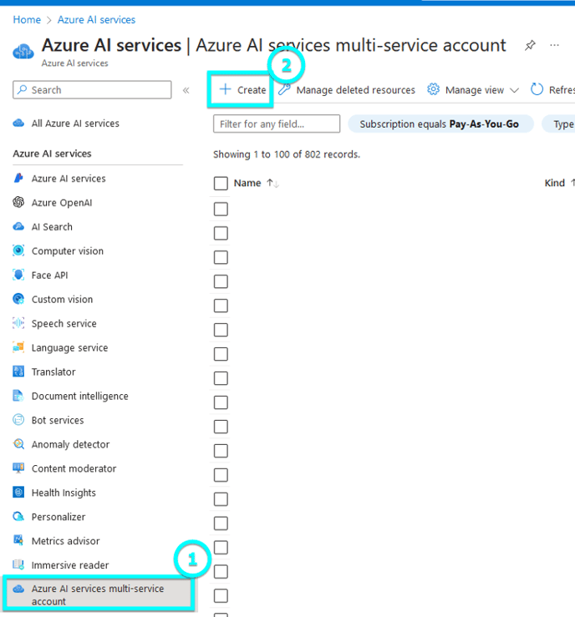

* + Access multiple Azure AI services with a single set of credentials.
  + Consolidates billing from the services you use.
* Single-service resource such as Face and Vision:

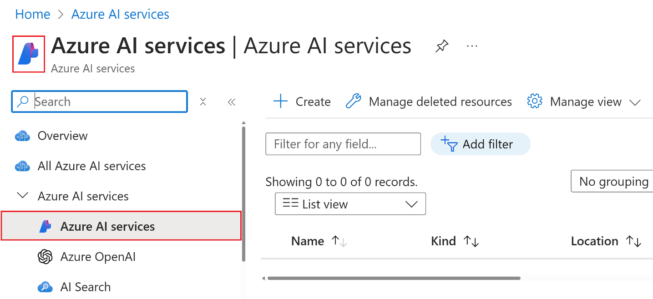

* + Access a single Azure AI service with a unique set of credentials for each service created.
  + Most Azure AI services offer a free tier to try it out.

**Create a new Azure AI services resource**

To create an Azure AI services resource, follow these instructions:

**Step 1 :** Create an Azure AI services resource

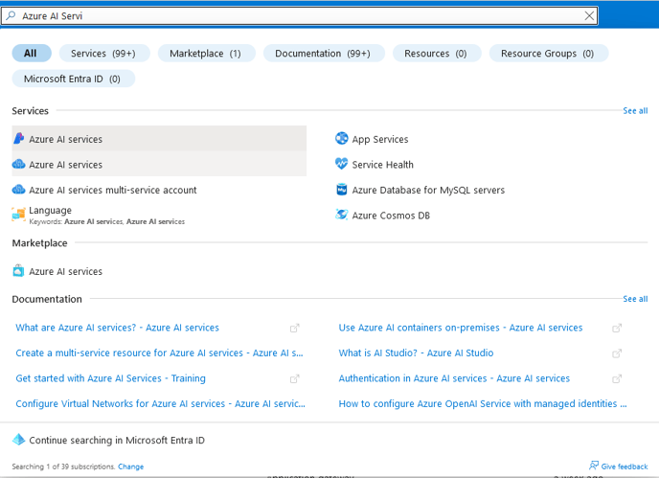

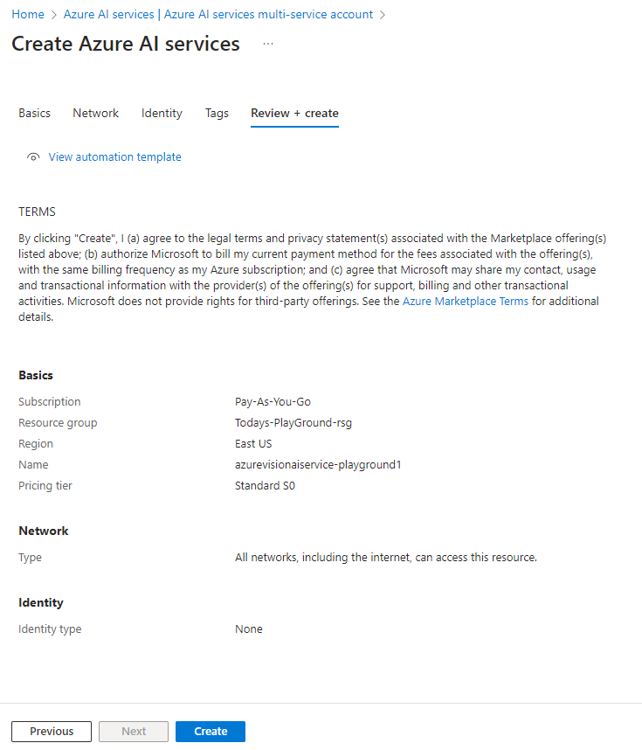

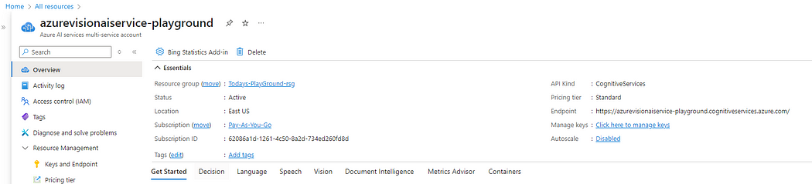

**Step 2 :** Connect your Azure AI service resource to Vision Studio

1. In another browser tab, navigate to Vision Studio at [https://portal.vision.cognitive.azure.com](https://portal.vision.cognitive.azure.com/?azure-portal=true).
2. Sign in with your account and making sure you are using the same directory as the one where you have created your Azure AI services resource.
3. On the Vision Studio home page, select View all resources under the Getting started with Vision heading.

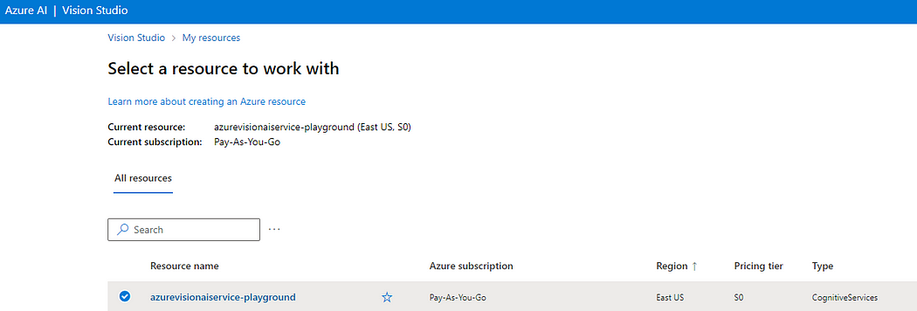

**Step 3 :** Extract text from images in the Vision Studio

On the portal, select Optical character recognition → extract text from images.

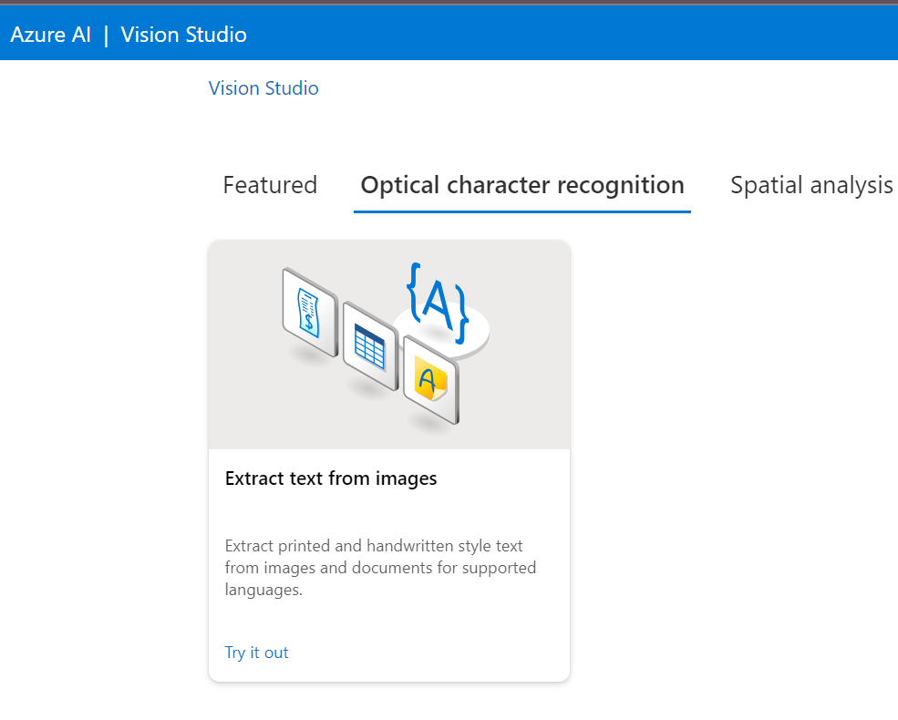

Browse for a file and navigate to the folder and select the image

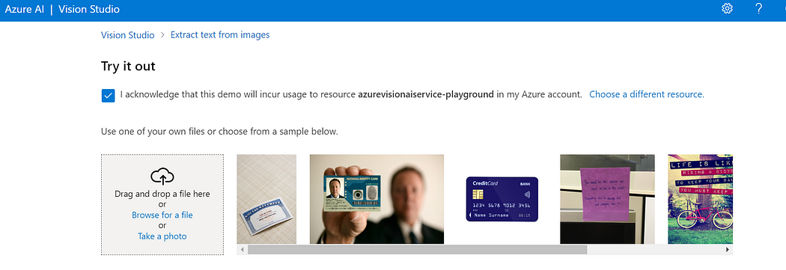

Observation : In Detected attributes, any text found in the image is organized into a hierarchical structure of regions, lines, and words.

On the image, the location of text is indicated by a bounding box as

below —

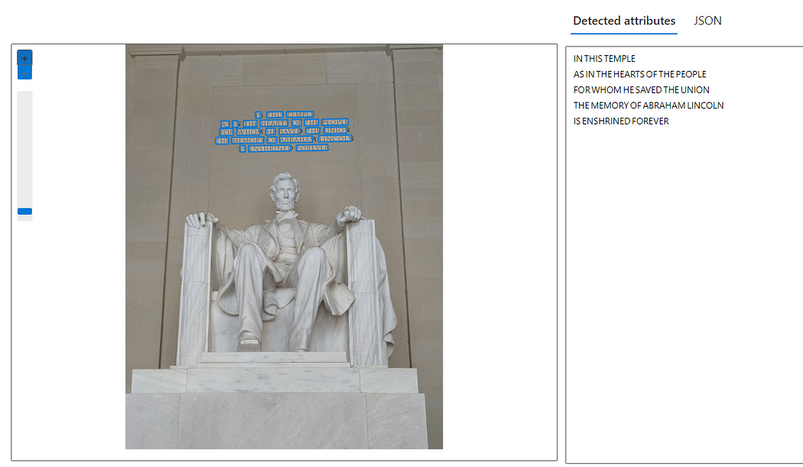

In JSON format too —

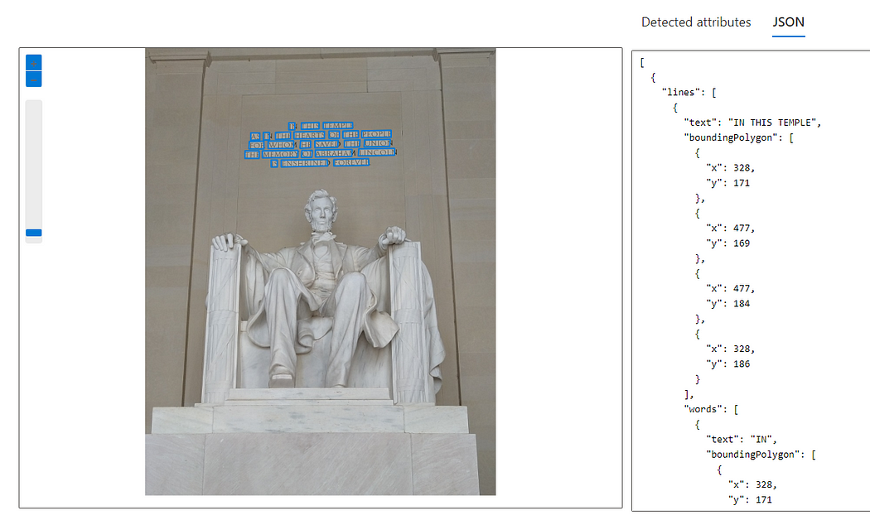

**Azure AI Custom Vision Services**

Azure AI Custom Vision is an image recognition service that lets you build, deploy, and improve your own **image identifier** models. An image identifier applies labels to images according to their visual characteristics. Each label represents a classification or object. Custom Vision allows you to specify your own labels and train custom models to detect them.

<https://learn.microsoft.com/en-us/azure/ai-services/custom-vision-service/>

**How it works**

The Custom Vision service uses a machine learning algorithm to analyze images for custom features. You submit sets of images that do and don't have the visual characteristics you're looking for. Then you label the images with your own labels (tags) at the time of submission. The algorithm trains to this data and calculates its own accuracy by testing itself on the same images. Once you've trained your model, you can test, retrain, and eventually use it in your image recognition app to [classify images](https://learn.microsoft.com/en-us/azure/ai-services/custom-vision-service/getting-started-build-a-classifier) or [detect objects](https://learn.microsoft.com/en-us/azure/ai-services/custom-vision-service/get-started-build-detector). You can also [export the model](https://learn.microsoft.com/en-us/azure/ai-services/custom-vision-service/export-your-model) for offline use.